**Project Report**

**Gadtardi Pratama Wongkaren 2301929480**

**Project: Snake Game using Python**

**Problem:**

A snake game implementing the material taught in class.

**Solution:**

Although there are many possible methods to create a snake game using the pygame module in python, this particular code uses most of the material learnt in class as well as a heavy and demonstrative use of Object-Oriented Programming.

**Reference**

Snake game taken from freecodecamp.org

Video: <https://www.youtube.com/watch?v=CD4qAhfFuLo>

Original un-annotated code: <https://pastebin.com/embed_js/jB6k06hG>

**Project Explanation**

The project creates a snake game using python’s pygame module. The game works by creating a “snake” that increases in length every time it eats a snack which is randomly generated on the level. If the “head” of the snake touches its own body, then the game is over. The objective of the game is to have the longest body of the snake as possible without the head of the snake ‘eating itself’.

**Project Components**

1. **The project uses the random, pygame, tkinter modules for python**

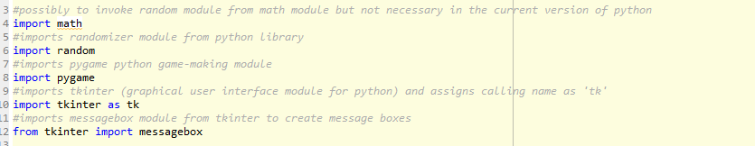

1. **The primary function and loop of the program**

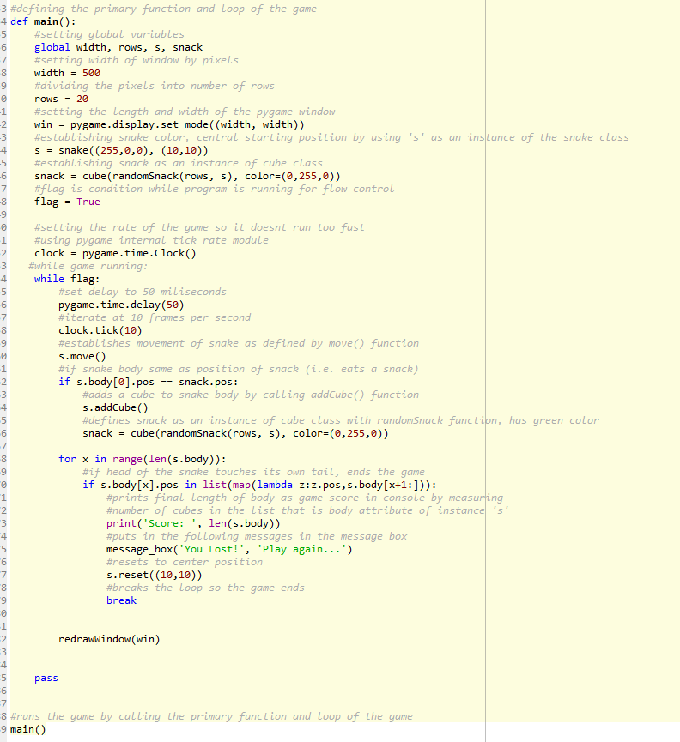

1. **The two main objects in the program are snake, and cube. The snake object is composed of cube objects.**

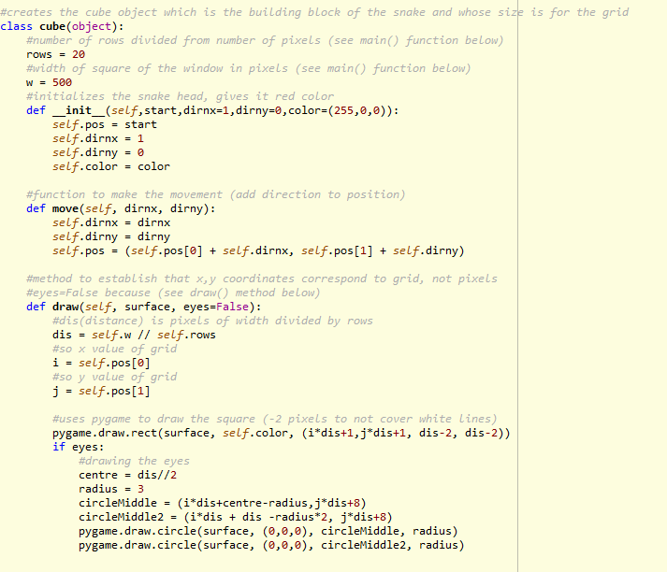

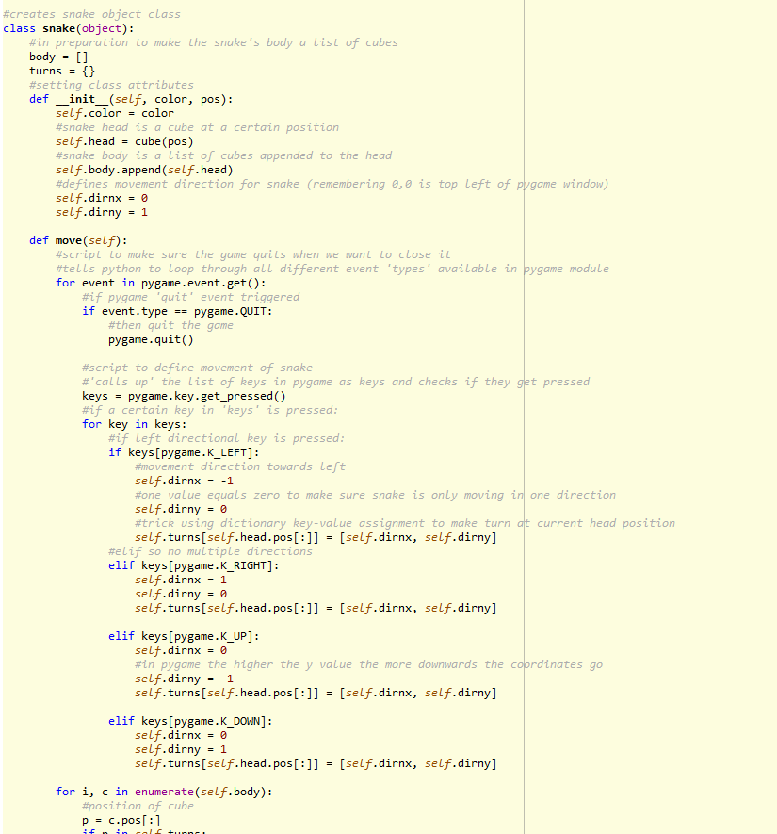

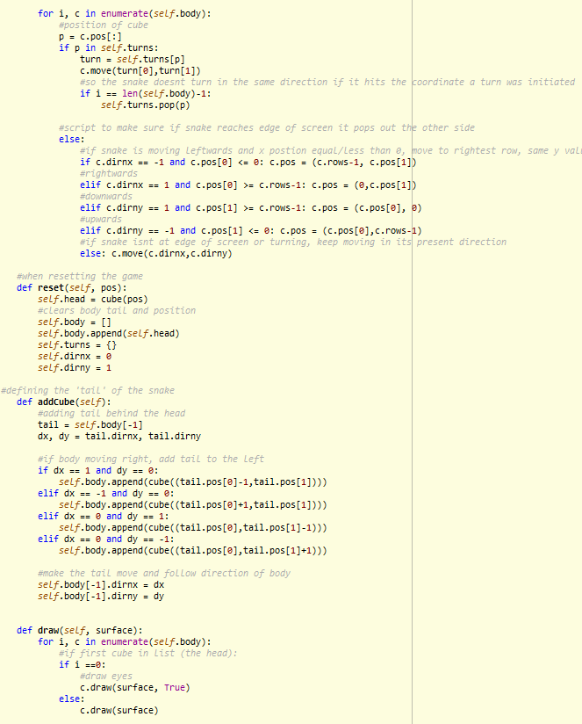

**Screenshot of program at work:**

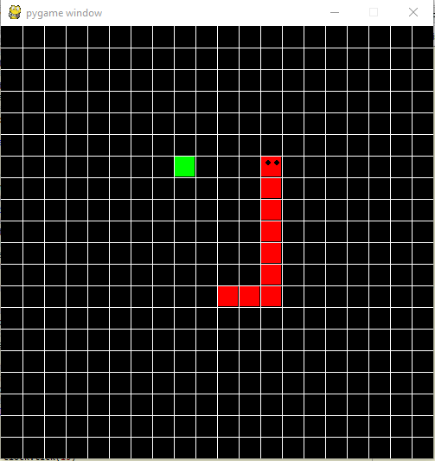

**Shortcomings of code:**

If snake has a tail already and is told to move in the direction of its own tail, the game will end. Possible solutions include clause where if snake told to move in direction of itself, command will be ignored.